**Institute of Engineering & Management**

**Department of Computer Science & Engineering**

**Communication Engineering Laboratory for 2nd year 4th semester 2018**

**Code: CS 491**

**Date:** 5/04/18

**ASSIGNMENT- 9**

**Experiment Name:** Pulse Width Modulation (PWM).

**Theory:** In PWM, the width of the modulated pulses varies in proportion with the amplitude of modulating signal. The amplitude and frequency of the PWM wave remains constant, only width of the pulse changes. That’s why information is contained in the width variation.

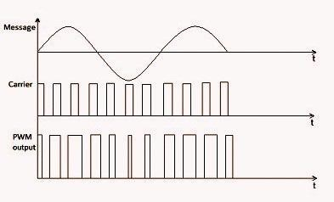

**Pulse width Modulation (PWM)**

**Circuit Diagram:**

|  |  |  |  |
| --- | --- | --- | --- |
| **Signal** | **Frequency** | **Amplitude** | **Offset** |
| Carrier Signal(pulse) | 44 Hz | 10 Vpp | 0V |
| Modulating  Signal(sine) | 10 Hz | 7 Vpp | 6V |

**Sample Data:**

**Waveform:**

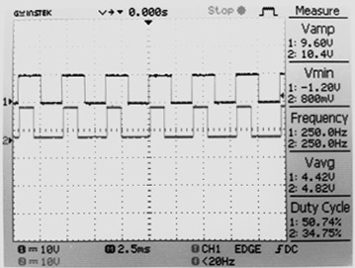

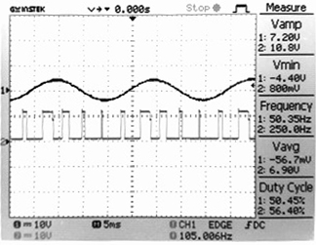 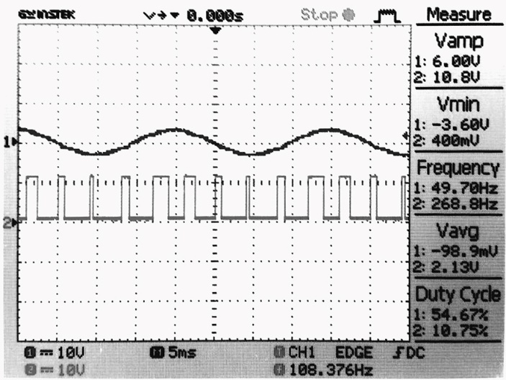

**Discussion:** In this Experiment, we have implemented the pulse width modulation using function generators to produce message and carrier signal.